EXERCISE 3(IMPLEMENTING LOGGING WITH SPRING AOP) EXERCISE 8 ALSO IMPLEMENTED(Implementing Basic AOP with Spring USING AUTO PROXY)

//REPOSITORY CLASS

package org.library;  
  
public class BookRepository {  
 public void getDetails(){  
 System.*out*.println("Book Repository is used");  
 }  
}

//BOOK SERVICE

package org.library;  
  
public class BookService{  
 private BookRepository bookRepository;  
  
 public BookService(BookRepository bookRepository) {  
 System.*out*.println("BookService Constructor is called.....");  
 this.bookRepository = bookRepository;  
 }  
  
public void display(){  
 System.*out*.println("Fetching the details form the repo.....");  
 bookRepository.getDetails();  
}  
}

//LOGGING ASPECT CLASS

package org.library;  
  
public class LoggingAspect {  
 public void beforeLoggingAspect(){  
 System.*out*.println("Before Logging Aspect called....");  
  
 }  
 public void afterLoggingAspect(){  
 System.*out*.println("After Logging Aspect");  
 }  
}

//MAIN CLASS

package org.library;  
import org.springframework.context.ApplicationContext;  
import org.springframework.context.support.ClassPathXmlApplicationContext;  
  
public class Main  
{  
 public static void main( String[] args )  
 {  
 ApplicationContext context = new ClassPathXmlApplicationContext("applicationContext.xml");  
 BookService bookService=(BookService) context.getBean("bs1");  
  
 bookService.display();  
 }  
}

//APPLICATION CONTEXT.XML

<?xml version="1.0" encoding="UTF-8"?>  
<beans xmlns="http://www.springframework.org/schema/beans"  
 xmlns:aop="http://www.springframework.org/schema/aop"  
 xmlns:xsi="http://www.w3.org/2001/XMLSchema-instance"  
 xsi:schemaLocation="  
 http://www.springframework.org/schema/beans  
 http://www.springframework.org/schema/beans/spring-beans.xsd  
 http://www.springframework.org/schema/aop  
 http://www.springframework.org/schema/aop/spring-aop.xsd">  
 <aop:aspectj-autoproxy/> //// EXCECRCISE 8 AUTO PROXY  
  
 <bean id="br1" class="org.library.BookRepository"/>  
  
 <bean id="bs1" class="org.library.BookService">  
 <constructor-arg ref="br1"/>  
 </bean>  
 <bean id="LoggingAspect" class="org.library.LoggingAspect"/>  
 <aop:config>  
 <aop:aspect ref="LoggingAspect">  
 <aop:pointcut id="repoMethods" expression="execution(\* org.library.BookRepository.\*(..))"/>  
 <aop:before method="beforeLoggingAspect" pointcut-ref="repoMethods"/>  
 <aop:after method="afterLoggingAspect" pointcut-ref="repoMethods"/>  
 </aop:aspect>  
 </aop:config>  
  
</beans>

//OUTPUT

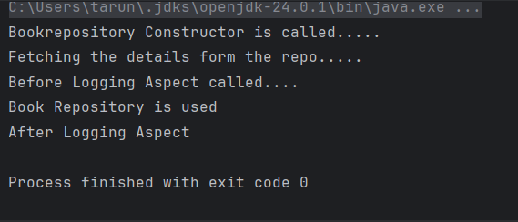

EXERCISE 5(CONFIGURING THE SPRING IOC CONTAINER)

//BOOK REPOSITORY CLASS

package org.library;  
  
public class BookRepository {  
 public void getDetails(){  
 System.*out*.println("Book Repository is used");  
 }  
}

//BOOK SERVICE CLASS

package org.library;  
  
public class BookService{  
 private BookRepository bookRepository;  
 public void setBookRepository(BookRepository bookRepository) {  
 System.*out*.println("Set bookrepository is called");  
 this.bookRepository = bookRepository;  
 }  
  
 public void display(){  
 System.*out*.println("Fetching the details form the repo.....");  
 bookRepository.getDetails();  
}  
}

//MAIN CLASS

package org.library;  
import org.springframework.context.ApplicationContext;  
import org.springframework.context.support.ClassPathXmlApplicationContext;  
  
public class Main  
{  
 public static void main( String[] args )  
 {  
 ApplicationContext context = new ClassPathXmlApplicationContext("applicationContext.xml");  
 BookService bookService=(BookService) context.getBean("bs1");  
  
 bookService.display();  
 }  
}

// APPLICATION CONTEXT.XML

<?xml version="1.0" encoding="UTF-8"?>  
<beans xmlns="http://www.springframework.org/schema/beans"  
 xmlns:aop="http://www.springframework.org/schema/aop"  
 xmlns:xsi="http://www.w3.org/2001/XMLSchema-instance"  
 xsi:schemaLocation="  
 http://www.springframework.org/schema/beans  
 http://www.springframework.org/schema/beans/spring-beans.xsd  
 http://www.springframework.org/schema/aop  
 http://www.springframework.org/schema/aop/spring-aop.xsd">  
 <bean id="br1" class="org.library.BookRepository"/>  
  
 <bean id="bs1" class="org.library.BookService">  
  
 <property name="bookRepository" ref="br1"/>  
 </bean>  
   
</beans>

//OUTPUT

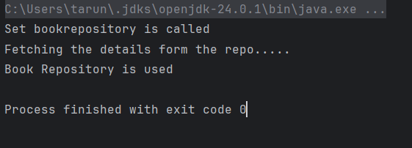

EXERCISE 6(CONFIGURING BEANS WITH ANNOTATIONS)

//BOOKREPOSITORY CLASS

package org.library;  
  
import org.springframework.stereotype.Component;  
import org.springframework.stereotype.Repository;  
@Component  
@Repository  
public class BookRepository {  
 public void getDetails(){  
 System.*out*.println("Book Repository is used");  
 }  
}

//BOOKSERVICE CLASS

package org.library;  
import org.springframework.beans.factory.annotation.Autowired;  
import org.springframework.stereotype.Component;  
import org.springframework.stereotype.Service;  
@Service  
@Component  
public class BookService{  
 @Autowired  
 private BookRepository bookRepository;  
 public void display(){  
 System.*out*.println("Fetching the details form the repo.....");  
 bookRepository.getDetails();  
}  
}

//MAIN CLASS

package org.library;  
import org.springframework.context.ApplicationContext;  
import org.springframework.context.support.ClassPathXmlApplicationContext;  
  
public class Main  
{  
 public static void main( String[] args )  
 {  
 ApplicationContext context = new ClassPathXmlApplicationContext("applicationContext.xml");  
 BookService bookService=context.getBean(BookService.class);  
  
 bookService.display();  
 }  
}

//APPLICATION CONTEXT.XML

<?xml version="1.0" encoding="UTF-8"?>  
<beans xmlns="http://www.springframework.org/schema/beans"  
 xmlns:context="http://www.springframework.org/schema/context"  
 xmlns:xsi="http://www.w3.org/2001/XMLSchema-instance"  
 xsi:schemaLocation="  
 http://www.springframework.org/schema/beans  
 http://www.springframework.org/schema/beans/spring-beans.xsd  
 http://www.springframework.org/schema/context  
 http://www.springframework.org/schema/context/spring-context.xsd">  
 <context:component-scan base-package="org.library"/>  
</beans>

//OUTPUT

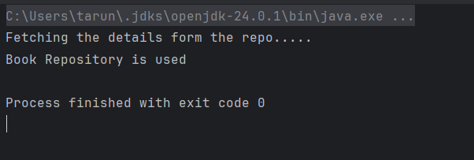

EXERCISE 7(Implementing Constructor and Setter Injection)

// BOOK REPOSITORY CLASS

package org.library;  
  
  
public class BookRepository {  
 public void getDetails(){  
 System.*out*.println("Book Repository is used");  
 }  
}

//BOOK SERVICE CLASS

package org.library;  
public class BookService{  
 public void setBookRepository(BookRepository bookRepository) {  
 this.bookRepository = bookRepository;  
 System.*out*.println("Setter is used");  
 }  
  
 public BookService(BookRepository bookRepository) {  
 this.bookRepository = bookRepository;  
 System.*out*.println("Constructor is called");  
 }  
  
 private BookRepository bookRepository;  
 public void display(){  
 System.*out*.println("Fetching the details form the repo.....");  
 bookRepository.getDetails();  
}  
}

//MAIN CLASS

package org.library;  
import org.springframework.context.ApplicationContext;  
import org.springframework.context.support.ClassPathXmlApplicationContext;  
  
public class Main  
{  
 public static void main( String[] args )  
 {  
 ApplicationContext context = new ClassPathXmlApplicationContext("applicationContext.xml");  
 BookService bookService=(BookService) context.getBean("bs1");  
  
 bookService.display();  
 }  
}

//APPLICATION CONTEXT.XML

<?xml version="1.0" encoding="UTF-8"?>  
<beans xmlns="http://www.springframework.org/schema/beans"  
 xmlns:xsi="http://www.w3.org/2001/XMLSchema-instance"  
 xsi:schemaLocation="  
 http://www.springframework.org/schema/beans  
 http://www.springframework.org/schema/beans/spring-beans.xsd">  
  
 <bean id="br1" class="org.library.BookRepository"/>  
 <bean id="bs1" class="org.library.BookService">  
 <property name="bookRepository" ref="br1"/>  
 <constructor-arg ref="br1"/>  
 </bean>  
  
</beans>

//OUTPUT

